Summary of the Route Analysis and Risk Assessment
  - Risk assessment of the route and measures taken

Name of the organisation: | Please enter text here.
Test vehicles used / vehicle categories: | Please enter text here.
Planned test period: | Please enter text here.
Use case according to AutomatFahrV: | Please enter text here.
Test scenario i: | Please enter text here.
Test track / Test area i: | Please enter text here.

AustriaTech | February 2025
Version 1.1

0 Document Information 3
1 Details on the person carrying out the preparation 3
2 Special features of the route 4
3 Phase 1 5
3.1 Risk types and anomalies - Phase 1 5
3.2 Risk assessment of the entire route after phase 1 (Table) 6
3.3 Risk assessment map after phase 1 7
4 Phase 2 8
4.1 Summary of infrastructure measures 8
4.2 Risk types and anomalies - Phase 2 9
4.3 Risk assessment of the route after phase 2 (Table) 10
4.4 Risk assessment map after phase 2 11
5 Phase 3 12
5.1 Summary of on-board, organisational, or other measures 12
5.2 Risk types and anomalies - phase 3 13
5.3 Risk assessment of the route after phase 3 (Table) 14
5.4 Risk assessment map after phase 3 15
6 Resume 16

Document Information
This Summary of the route analysis and risk assessment serves as an overview of identified risks, mitigation measures and general findings from the process carried out. It is intended to summarise the most important information and ensure easy analysis.
This summary is based on the route analysis and risk assessment. It is not bound to a specific format but must include all the contents of the AustriaTech template for the route analysis and risk assessment.
However, this document must be used to summarise the results in order to ensure completeness and uniformity.
For the photo documentation provided in this document, the existing regulations, such as the Data Protection Act / the General Data Protection Regulation (GDPR) or the Road Traffic Act (StVO), must be observed in any case. Thus, when taking photos, care must be taken to ensure that faces and license plates, for example, are rendered unrecognisable.

Details on the person carrying out the preparation
The person responsible for the preparation must be named. This person can be contacted by the Federal Ministry for Climate Action, Environment, Energy, Mobility, Innovation and Technology (BMK) and the Contact Point Automated Mobility if necessary and must be able to provide information.
First and last name: | Please enter text here.
Organisation: | Please enter text here.
Position: | Please enter text here.
Phone number: | Please enter text here.
E-Mail address: | Please enter text here.

Special features of the route
What are the special features of the selected test route / test area? What criteria were used to segment the route? What general risks need to be considered? (The characteristics of the vehicle and the automated driving system must also be taken into account in this consideration.)
Please enter text here.

Phase 1

Risk types and anomalies - Phase 1
Phase 1 involves an initial risk assessment of the individual route sections. Which sections present a particularly high risk? Where do typical clusters form? Emphasise any particular anomalies.
Please enter text here.

Risk assessment of the entire route after phase 1 (Table)
Risk assessment per section in tabular form (several risk levels). According to table 2 from the template for route analysis and risk assessment (base document).
Table 2: Template for the risk assessment of the entire route in phase 1
Route section | Risk potential
Section 1
Section 2
Section 3
Section …
Overall risk of the route i

Please enter text here.

Risk assessment map after phase 1
Risk assessment for each section visualised on a map (several risk levels).
According to Figure 3 from the template for route analysis and risk assessment (base document).
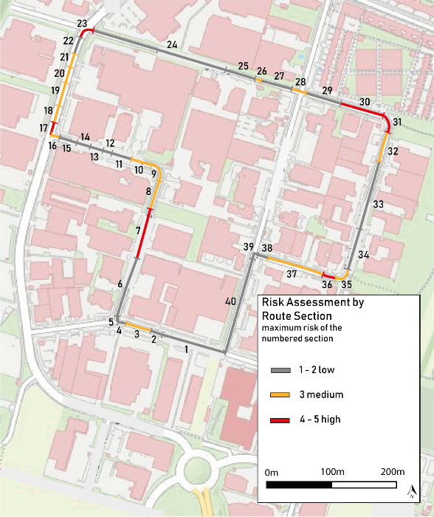
Figure 3: Example of a results map of the risk assessment by route section (own illustration)
Please enter text here.

Phase 2

Summary of infrastructure measures
In phase 2, for all existing critical sections with medium (3) or high (4-5) risk, appropriate infrastructure-related precautions and measures are determined to mitigate the risk (mitigation measures).
Please enter text here.

Risk types and anomalies - Phase 2
Which route sections are at high risk even after the implementation of the infrastructural mitigation measures? Where do typical clusters form? Emphasise any particular anomalies (including references to the corresponding measures).
Please enter text here.

Risk assessment of the route after phase 2 (Table)
Risk assessment per section in tabular form (several risk levels). According to table 4 from the template for route analysis and risk assessment.
Table 4: Template for the risk assessment of the route in phase 2
Route section | Risk potential Phase 1 i | Risk potential Phase 2 i
Section 1
Section 2
Section 3
Section …
Overall risk of the route i

Please enter text here.

Risk assessment map after phase 2
Risk assessment for each section visualised on a map (several risk levels).
According to figure 3 from the template for route analysis and risk assessment (base document).
Please enter text here.

Phase 3

Summary of on-board, organisational, or other measures
In phase 3, for all remaining critical sections with medium (3) or high (4-5) risk, appropriate on-board, organisational, or other adequate precautions or measures are determined to mitigate the risk (mitigation measures).
Please enter text here.

Risk types and anomalies - phase 3
Which route sections are at high risk even after the implementation of the on-board, organisational, or other mitigation measures? Where do typical clusters form? Emphasise any particular anomalies (including references to the corresponding measures).
Please enter text here.

Risk assessment of the route after phase 3 (Table)
Risk assessment per section in tabular form (several risk levels).
According to table 6 from the template for route analysis and risk assessment (base document).
Table 6: Template for the risk assessment of the route in phase 3
Route section | Risk potential Phase 1 i | Risk potential Phase 2 i | Risk potential Phase 3 i
Section 1
Section 2
Section 3
Section …
Overall risk of the route i

Please enter text here.

Risk assessment map after phase 3
Risk assessment per section visualised on a map (several risk levels).
According to figure 3 from the template for route analysis and risk assessment (base document).
Please enter text here.

Resumee
What general findings were drawn from the route analysis and risk assessment? How are these to be categorised?
Please enter text here.

